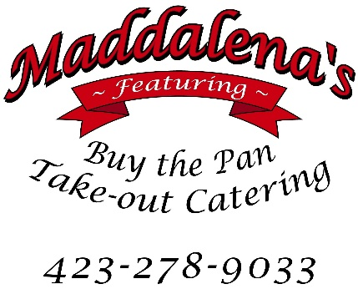
200 Bohannon Avenue
Greeneville, TN 37745
buythepantn@gmail.com
www.maddalenasfeaturingbuythepan.com

Daily Deli Specials.
Salad and dessert specials daily.
Fresh fruit, assorted chips, and beverages.

Meat Choices | Sandwich or 6 Inch Sub | 12 Inch Sub
Italian (Ham, Capicola, Salami, Provolone) | $6.50 | $12.99
Ham | $5.50 | $10.99
Turkey Breast (Maple Honey) | $6.00 | $11.99
Roast Beef | $7.50 | $14.99
Salami | $6.00 | $11.99
Mozzarella, Vermont Cheddar, Yellow American, White American, Muenster, Domestic Provolone, Baby Swiss, Monterey Jack | Add $1.00
Bacon | Add $1.00
Bread: Kaiser Roll, White, Brioche, Wheat
Sub Roll: White or Honey Wheat
Condiments: Oil & Vinegar, Mayonnaise, Chipotle Mayo, Honey Mustard, Deli Style Mustard, Horseradish Sauce
Choice of Toppings: Lettuce, Tomato, Onion, Black Olives, Banana Peppers, Hot Peppers, Pickle Chips, Salt, Pepper, Oregano

